Stamp Game: Static Division
Materials: 9-thousand paper stamps, 20-hundred paper stamps, 20-ten paper stamps, 20-unit (ones) paper stamps
Prerequisite: familiar with the idea of division
Control of Error: adult
Aim: preparation for abstract division
Point of Interest: dividing up a big number of stamps
Presentation:
- Set up work at a table or mat
- Adult will write out division problem on the paper worksheet or reusable paper
- Take out corresponding thousands, hundreds, tens and units from the top number on paper and place stamps towards the top of the table or mat
- Explain to the child that you will be dividing up a bigger number into equal smaller numbers
- Take out corresponding skittles for the single-digit divisor
- Divide up thousands, then hundreds, then tens, then units for each skittle
- Record answer on the paper after counting each skittle category
- Replace the stamps
- Allow the child to work independently
- Stack numbers accordingly and place back inside of the envelope
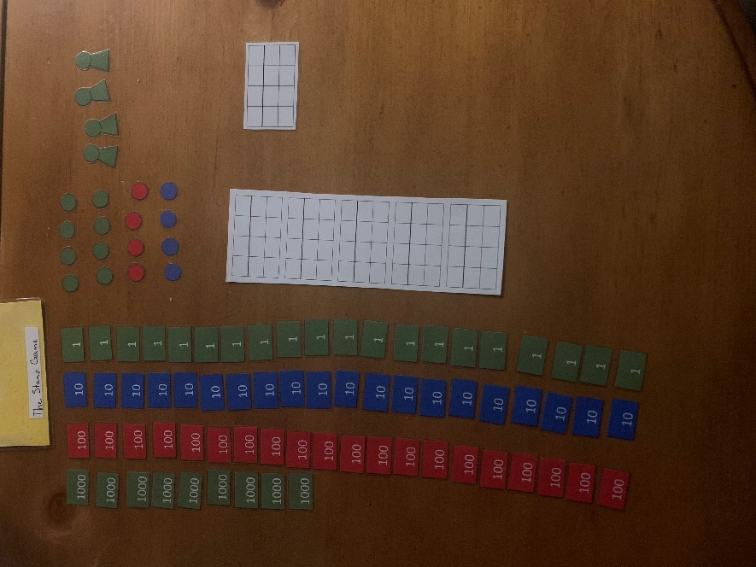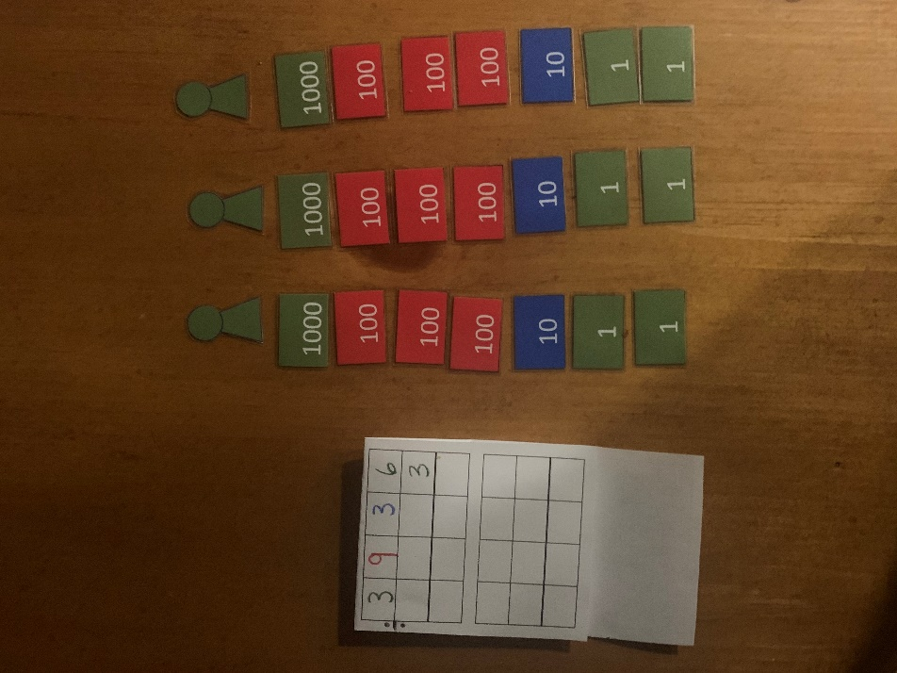

Variations- do not use paper to write out problem
Extensions: make a story problem and solve it using the stamps

