**Stamp Game: Multiplication**

**Materials:** 9-thousand paper stamps, 20-hundred paper stamps, 20-ten paper stamps, 20-unit (ones) paper stamps, paper and pencil

**Prerequisite:** familiar with the idea of multiplication

**Control of Error:** adult

**Aim:** preparation for abstract multiplication

**Point of Interest:** working with the stamps and doing a multiplication problem

**Presentation:**

1. Set up work at a table or mat
2. Adult will write out multiplication problem on the paper worksheet or reusable paper
3. Take out corresponding thousands, hundreds, tens and units from the top number on paper and place stamps towards the top of the table or mat
4. Explain to the child that you will be taking out the number as many times as the problem says (2 times), reiterate that multiplication is about adding the same number over and over again
5. Take out the next set of stamps leaving space from the bottom of the top number
6. Slide all like categories together
7. Count all ones, then tens, hundreds, thousands
8. Record answer on the paper after counting each category
9. Replace the stamps
10. Allow the child to work independently
11. Stack numbers accordingly and place back inside of the envelope

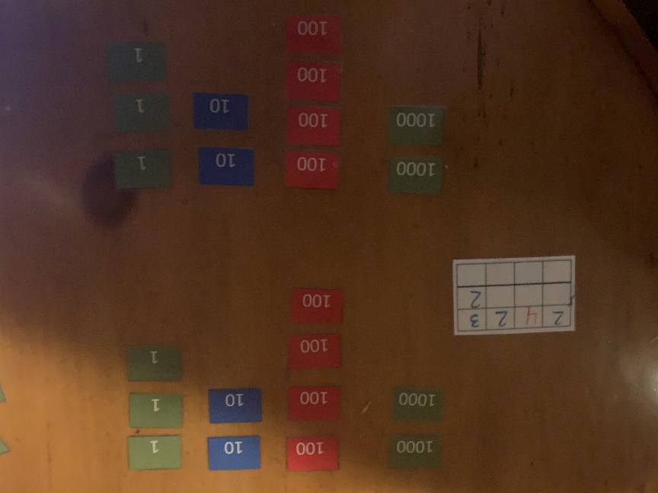

**Extensions:** use different multiplication materials to check answer

**Variables:** do not record answer-memorization