**The Short Bead Stair-Division**

**Materials-** two sets of The Short (paper) Bead Stair (1 red bead, 1 green bead, 1 pink bead, 1 yellow bead, 1 light blue bead, 1 purple bead, 1 white bead, 1 brown bead, 1 dark blue bead, 1 golden bead), two sets of numbers 1-10, one set of numbers 1-20, division and equals sign

**Prerequisite-** mastery of; The Short Bead Stair, recognition of numbers 0-20 addition and multiplication, the understanding that division is about dividing a big number up to make smaller numbers

**Control of Error- *adult is the control of error-can only do static division which requires the use of specific numbers\***

**Aim:** to divide numbers

**Point of Interest:** making smaller numbers

**Language:** divide, division, equals

**Age:** 4 and up

**Presentation:**

1. Set up two of The Short Bead Stairs side by side
2. Place the corresponding numbers next to each bead
3. Line up the numbers 1-20 towards the bottom of the table or mat
4. Place the multiplication and equals sign towards the top of the table or mat
5. Pick a bead from the first Short Bead Stair made-preferably a bigger number
6. Place the corresponding number under the bead
7. Explain to the child that the next number is how many times we will divide the big number up
8. Pick up the division sign and explain to the child what it symbolizes
9. Place the sign next to the first number picked
10. Pick a bead from the second Short Bead Stair-make sure the first number is divisible by the second number (example 9 and 3)
11. Place the bead next to the first bead picked
12. Place the corresponding number under the second bead picked
13. Explain to the child “we are imagining that we are dividing this number (the first number) evenly between (the second number). What new number would we make?”
14. Help the child figure out the correct answer
15. Find the answer amongst the numbers 1-20
16. Place the equals sign next to the second number picked
17. Place the answer to the right of the equals sign
18. Put all beads, numbers and operation signs away in correct spots
19. Continue to make more equations
20. To put work away stack each number, paper bead and operation symbol separately
21. Place all the materials inside of the envelopes

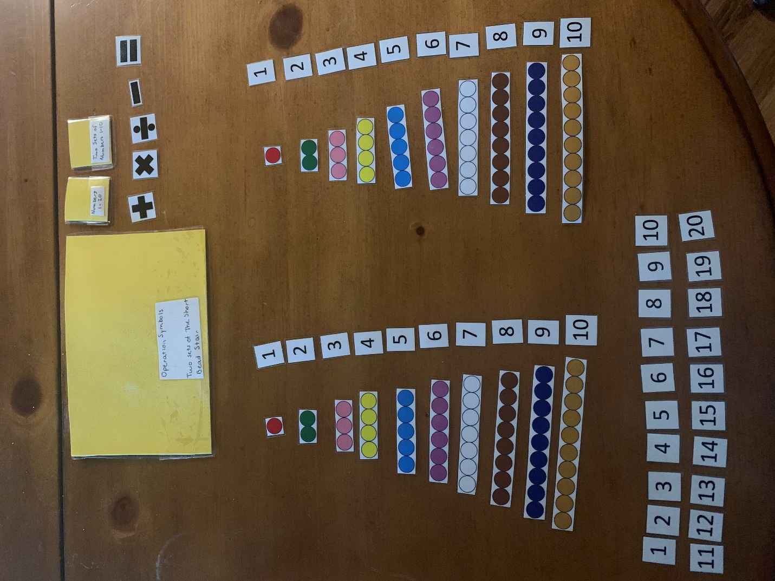

**Variations-** use numbers bigger than 10 when setting up the equation

**Extensions-** use cheerios to help divide up numbers