The (Paper) Stamp Game: Static Addtion
Materials: 9-thousand paper stamps, 20-hundred paper stamps, 20-ten paper stamps, 20-unit (ones) paper stamps, pencil and paper
Prerequsite: familiar with the idea of addition
Control of Error: adult
Aim: preparation for abstract addition
Point of Interest: solving a problem
Presentation:
- Set up work at a table or mat
- Adult will write out an addition problem on the paper worksheet or reusable paper
- Take out corresponding thousands, hundreds, tens and units from the top number on paper and place stamps towards the top of the table or mat
- Leaving a space from the top number, take out corresponding thousands, hundreds, tens and units from the bottom number on paper and place stamps under the first set of stamps
- Slide all ones together, then tens, hundreds, thousands
- Count all ones, then tens, hundreds, thousands
- Record answer on the paper after counting each category
- Replace the stamps
- Allow the child to work independently
- Stack numbers accordingly and place back inside of the envelope
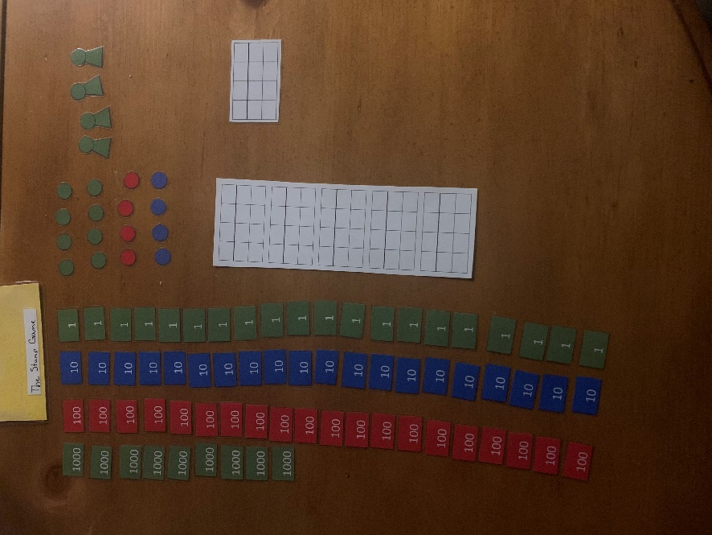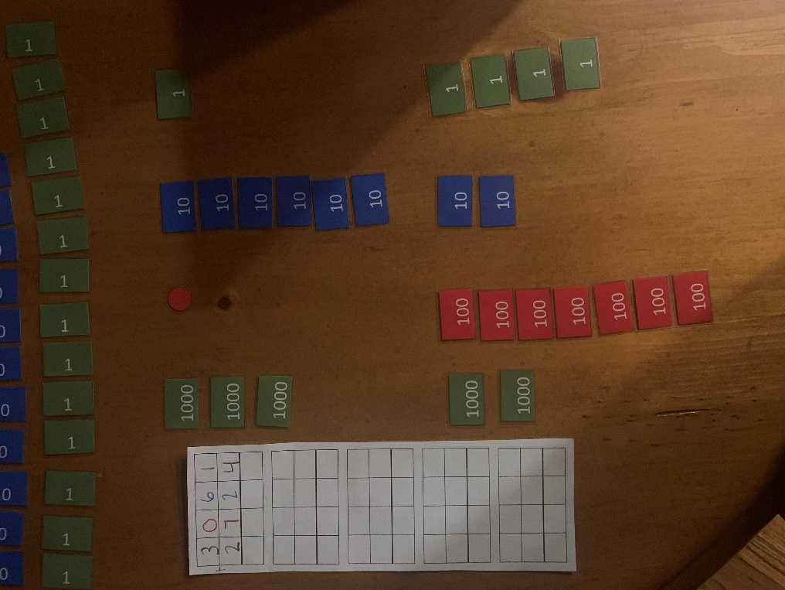

Extensions: check work with other addition materials at home
Variations: use only regular pencil, have adult write problem and answer

